Year 9 Industrial Technology - Timber

Theory Book

Name:

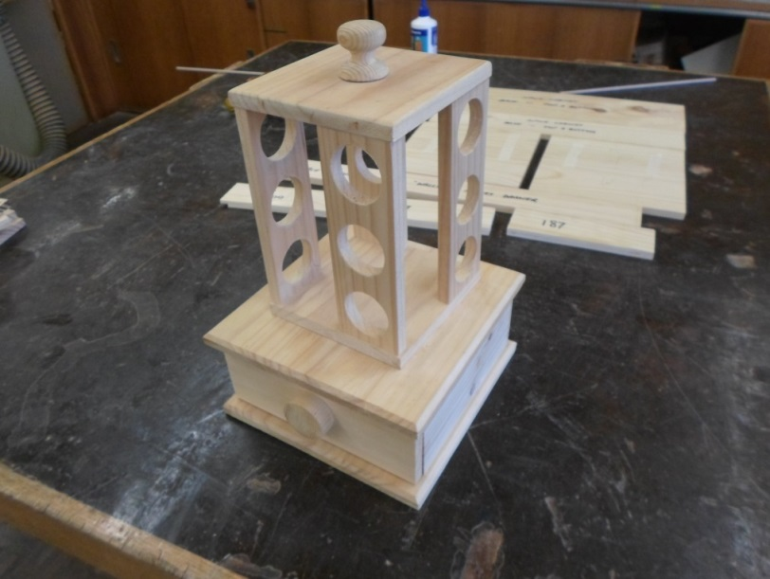

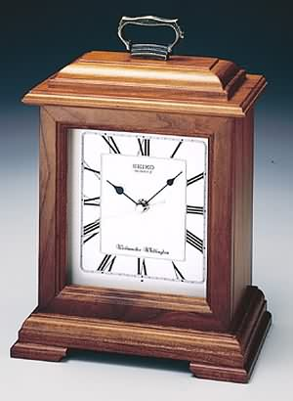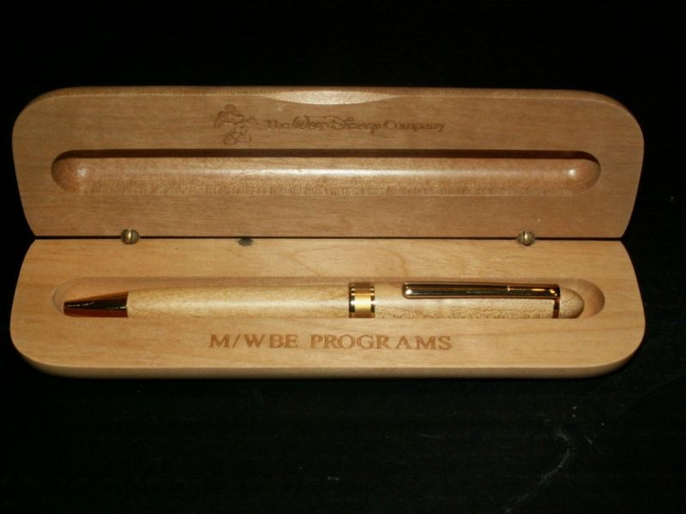

Book Rules
- Tasks must be completed in Word.

Requirements
All students must complete this theory book during the theory periods. A Word document for each task is required. Work handins will b eon USB or email, as directed.
Eye protection is a major concern in any workshop and a strict policy of gaining entry into these classes is for all students to supply their own Safety Glasses or use the supplied sets. Eye protection is required for use with machines, power tools, welding and chemicals.
The subject fee for all elective subjects is compulsory. For students to take any completed projects home they must have paid the fee in full, made a part payment or applied through the Student Assistance fund at the school.
Major projects at the end of each year may attract extra cost above the compulsory set fee.
Covered shoes must be worn in the workshop at all times.

Assessment Policy
Your assessment at the end of each semester will be made up from the following: -
Practical Projects ----------------------------- 60%
Class Tests ------------------------------------ 15%
Theory Book ---------------------------------- 10%
Assignments ---------------------------------- 15%
Total ------- 100%

All assessment tasks must be completed and submitted on the due dates, otherwise a zero mark will be awarded. The task will still have to be completed for the student to successfully complete the course.

Homework Policy
Homework will be the completion of work that is not finished in the allocated theory times. If a student is absent, it is their responsibility to find out and complete what was missed.
Theory class time will be given to assignments to teach students research skills on computers but most assignment work will be set as homework.

Spelling Policy
A list of key words will be introduced with each theory topic. Students will be required to put these into a Spelling List in the back of this booklet for future reference. By the end of the course students will be expected to be able to spell and define these words.
Crosswords, find-a-words and other language activities will be introduced throughout this booklet.

Employment Related Skills Sheets
Within this booklet, sheets have been provided to give the students an opportunity to collect information relating to skills they gain in this subject area in order to prepare a resume and better understand what courses and careers to select in the future. This information can then be collated in the ‘Employment Related Skills Logbook’ issued to students by the Department of Education and Training.

Parents
We would very much appreciate your help, as parents/guardians, in your child’s education. If you could at times check this book and encourage your child to improve his/her standard of neatness, computer skills and completion of work.

Module 1

SAFETY INFORMATION
The purpose of this document is to ensure standardised instruction in the safe use of equipment. There are many other safety procedures to be followed when using the equipment depending on the procedure being carried out. The list below indicates the important rules to be observed for particular equipment at all times. A more detailed list will be discussed as the equipment is introduced during the practical lessons and in theory.

GENERAL/ WORKSHOP
Appropriate dress: including footwear; loose clothing; unrestrained hair.
Protective equipment: safety glasses; earmuffs
Movement: restricted; safety zones carrying and storing equipment
Safety zones: only operator inside marked zones around machines
Electrical equipment: check leads are in good order and all guards are in place, wait until machine reaches operating speed before using and is stopped before putting down or leaving, keep fingers clear and use push sticks, ensure dust extractor is on.

BISCUIT JOINER
Secure work to overhang bench
Ensure leads are in good condition and free from work area
Start machine before engaging cutters
Hold with both hands

DISC SANDER
Hold work flat on table
Use downside of disc
No small pieces of wood

LINISHER
Gradually introduce pressure
Keep fingers away from guard
No small pieces

DRILL - PEDESTAL
Secure work piece and drill bit
Restrain long hair
Remove chuck key

DRILL - PORTABLE
Secure work and drill bit
Hold drill with both hands
Remove chuck key
LATHE - WOOD
Revolve work by hand before switching on
Stand aside when switching on
Adjust tool rest to appropriate height and distance from work
Remove rest before sanding
Check timber for defects

ORBITAL/PALM SANDER
Light pressure with good condition paper
Use only on flat surfaces, not edges
Ensure cord is free

PLANER-PORTABLE ELECTRIC
Begin with toe on work, cutter clear
Hold with both hands
Keep hands above sole

PLANER-THICKNESSER
No short pieces; roller-to-roller lengths
Stand aside when operating
Take several gradual cuts to avoid overload on wide pieces
Wear earmuffs

ROUTER - PORTABLE ELECTRIC
Secure work, cutter and fences (if used)
Motion to oppose cutter rotation
Ensure cord is clear
Remove cord from power point before making adjustments
Hold with both hands when switching on, and until stopped
Wear earmuffs

SAW - BANDSAW
Adjust guide to just clear work
Hands to side, not in line with blade
Use push sticks to complete final stage
Only cut cylindrical work if it is supported
Don’t back out of cuts, or cut tight curve

SAW - DROP SAW
No short pieces
When using a stop (for repetitive lengths) secure timber between blade and stop
Only cut one piece at a time

SAW - RADIAL ARM
Fully extend before starting cut

SAW - PORTABLE JIG
Secure work with cut area overhanging bench
Hold saw down on work piece before switching on and until blade stops

SAW - SCROLL
Hold work down on table
Keep fingers clear
Fix blade with teeth facing downwards

MACHINE/PORTABLE EQUIPMENT USAGE AND SAFETY RECORD

The table below indicates the class/year group able to use the listed equipment, following appropriate safety instruction.

MACHINE/POWER TOOL | YEAR | STUDENT DIGITAL SIGNATURE | DATE | DIGITAL INITIAL
General/workshop | 7
Biscuit Joiner | 9
Disc Sander/Linisher | 9
Drill - Pedestal | 7
Drill – Portable (Powered) | 9
Lathe - Woodturning | 8 or 9
Orbital/Palm Sander | 7
Planer - Portable electric | Set-up only
Planer/Thicknesser | 9 or 10
Router - Portable | 9
Saw - Bandsaw | 10*
Saw - Circular Bench | Set-up only
Saw - Circular Portable | Set-up only
Saw - Drop | 11
Saw - Portable Jig | 9
Saw - Scroll | 7
Please sign and date to indicate you have received safety instruction, in your practical lessons and to indicate you feel confident in the safe use of the equipment. Your teacher will initial to authorise your use of each piece of equipment.

Year 9 & 10 Technics Wood Assignment No:1

Risk Management “Safety Signs”

SAFETY SIGNS
Safety signs provide a graphic reminder of safety requirements in the workplace and should be placed in a conspicuous position as close as possible to the location where the hazard or safety requirement exists.

Electrical hazard or danger of electrocution

Risk management:
Is the process of recognising situations, which have the potential to cause harm to people or property, and doing something to prevent the hazardous situation occurring or the person being harmed.
Just like a problem-solving process, risk management involves:
Step 1: Identifying the problem, which is known as hazard identification.
Step 2: Determining how serious a problem it is, known as risk assessment.
Step 3: Deciding on what needs to be done to solve the problem, known as risk elimination or control.

Your Task
A) In Word
Identify a situation in the woodwork room that has the potential to cause harm to people or property.
Assess the risk and explain how serious the problem could be and what injuries may occur
Design an appropriate safety sign that could be used to eliminate or control the risk. (Remember that safety signs are colour coded) Sketch the design in your book and use call-out notes to highlight your design ideas. Show your idea to your teacher before commencing the next step.

B) In Word do a full size finished product of your sign for the woodwork room. This assignment is to be very neat and well presented. If not you will be asked to do it again.

Assignment 1. Marking Schedule.
Put this sheet in your A4 Loose Leaf Folder so that it can be used to calculate your assignment mark.
Marking Indicators

Possible marks | 8-10 |  | 5-7 |  | 2-4 |  | 1
Identifying a hazard | A well defined hazard that is clearly linked to activities in the wood room |  | A hazard that is not clearly identified but is associated with wood activities |  | A poorly defined hazard that may be linked to the activities in the wood room |  | A very poorly defined hazard that is not linked to wood activities
Total for question 1 /10
Possible marks | 8-10 | 5-7 |  | 2-4 |  | 1
Access the risk and explain seriousness of injuries | A clear, easy to read assessment that has evidence of thought, research and presentation | Adequate information for the question but little evidence of research |  | Very limited information with no evidence of research or planning |  | Copied information without any modification or any thought towards presentation
Total for Question 2 /10
Possible  marks | 8-10 | 5-7 |  | 2-4 |  | 1
Initial Design Ideas | Clearly defined ideas that shows progressive development, concepts,research and thoughts on presentation | A reasonable idea that does not show progressive development or research |  | Poor ideas without evidence of research or thought of presentation |  | Copied idea without any thought of presentation
Total for question 3 /10
Possible  marks | 8-10 | 5-7 |  | 2-4 |  | 1
Final A3 Poster | High quality presentation displaying thought and skill. Sign meets safety sign guidelines /recomendations | A good presentation that has evidence of time and effort and needs few words |  | Poor ideas without evidence of research or thought of presentation. Requires a directive to explain symbol |  | Copied idea without any thought of presentation
Total for question 4 /10

Total assignment mark. …../40

Unit 2:Timber; Features and Marketing.

Complete the following sentences using the word list below and the knowledge you have gained from the practical lessons.

- Most timbers have a definite grain , which is determined by the arrangement of fibres and associated wood elements.

- Timber length must be measured in the direction of the

- A piece of timber has been sketched below in ISOMETRIC PROJECTION and the of this piece has been shown as “L”

- On the diagram of a piece of timber below, indicate its length with “L”. Place “W” for Width between the appropriate arrows and do likewise with “T” for Thickness. Refer to the diagram explain which direction the grain is.

5. The three dimensions of a piece of timber are (1) , and (2)
And (3).

6. Boards, which are sold with their sawn surface conditions unchanged, are classed as sawn.

Word List: Length Grain Thickness Direction Rough Width

- On the diagram of a piece of timber below indicate its Face Side and Face Edge using the conventional marking symbols. Show the grain figure onto the timber to indicate its direction.

Face Side
End

Face Edge

8. A board, which is sold with one or more surfaces planed, is classed as
A board that has all surfaces planed is classed as .

9. Boards which are sold after being shaped in some way are classed as .

10. The dimensions of and together provide us with a cross sectional or size.

Word List: Thickness Moulded Dressed Board Width DAR (Dressed All Round)

Write the following words into your spelling list:

Thickness Moulded Dressed Board Width

Module 3

Joints used in wood work

1. What is the mark of a good craftsman?

2. What are the most common reasons as to why timber splits?

3. To ensure accurate assembly of joints, you need to pay particular attention to what?

4. List the three classifications of timber joints.

1
2
3

Box or Angle Joints:

5. What are Box or Angle Joints generally used for?

6. The three main types of Box joints are:

A
B
C

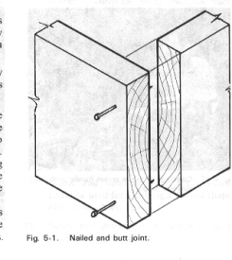
7. Where is this joint most commonly used and how can it be made stronger?

8. Explain why the quad placed on the internal angle of the butt joint?

…………………………………………………………………………………………………………….

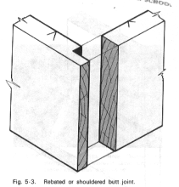
- What has been done to this butt joint and why?

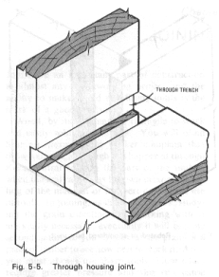

10. Name this joint:

How deep can the trench be made?

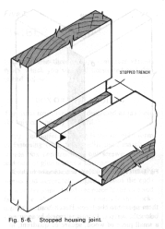

11. When is a stopped trench used?
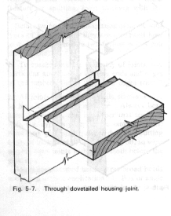

12 Name this joint:

Why would this be stronger than a common through housing joint?

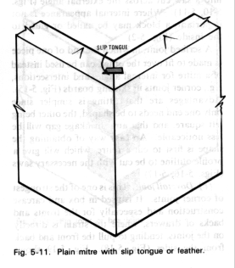
13. Mitred joint.
The mitre joint is a form of what other joint?

14. The advantage of the mitre joint is;

15. What makes a true mitre joint?

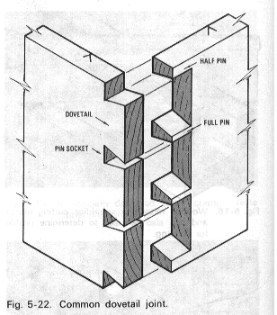
16.Dovetail Joints.
This is one of the of corner joints. It is used in and
construction.
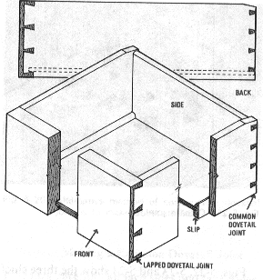

It is especially used for where the strain is directly on the joints, tending to pull the fronts and backs from the sides.

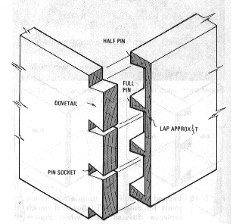
17. Name this dovetail joint (right): .

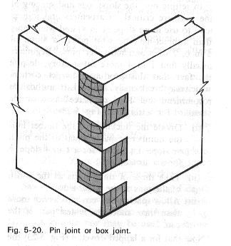

18.Name this joint (left).

It is a variation of what other joint? …………………………………………………………………………………………………………….

Framing Joints

19. These joints are used constructions, where the members are usually joined , with their edges at angles. The face sides of the members are usually flush.

The five chief types of framing joints are

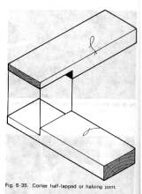
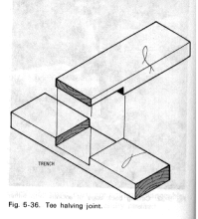
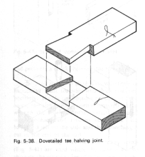
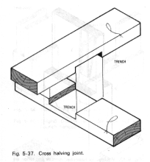
20.Name the following Halving Joints.

21. The depth for both lap and recess must be gauged always from the face side.
What will always happen in a properly made halving joint?
Answer; The faces will always,
Add the following words to your spelling list.
Craftsman Material Halving Mitre Dovetail

Framing Joints Continued:

1) Mortise and tenon joint is one of the most and joints
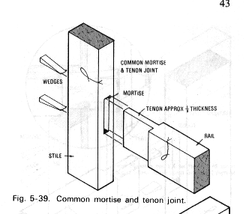
used in frames.

2) The thickness of the tenon is equal to approximately
. i.e. to the nearest chisel size.

3) Why make the tenon the same size as the closest chisel?
4) Note the addition of wedges at both edges of the tenon.
What do these compensate for?
5) The haunched mortise and tenon joint.
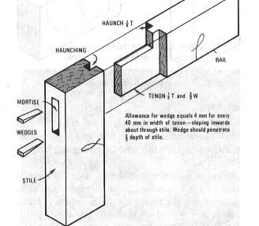
What does the haunch provide?

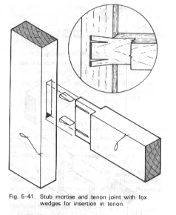
6) Stub or stump mortise and tenon joint.
Where are these used?

7) A barefaced mortise and tenon are used where?
The tenon has a shoulder on one side only.

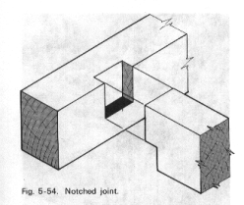
8) Name this joint.

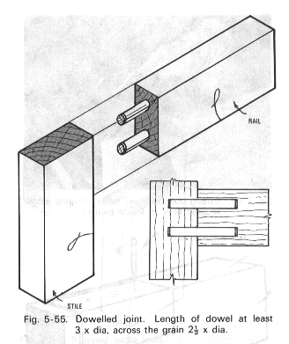
9) The advantages of the Dowelled joint are
…………………………………………………………………………………………………………………………………………………………………………………………………………………………………………………………………………………………………………………………………………………………………………

10) Name the following types of bridle joint.
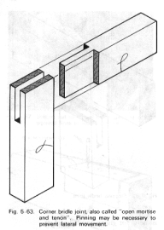
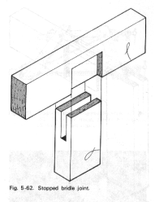
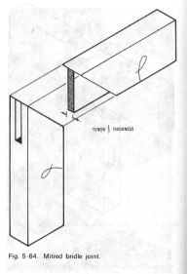
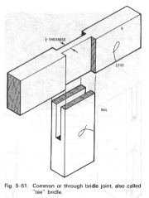

Widening Joints
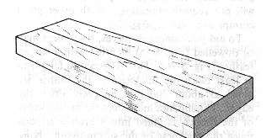
11). "Widening joints" are those joints where boards are joined
12) The most common form of widening joint is?

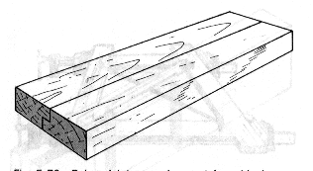
13) Name the following widening joint.
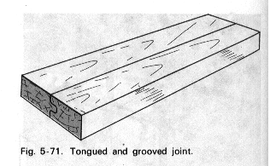

Others usually made mechanically rather than by hand are tongued and grooved, dovetailed, and machined in corrugated shape.

14) In all of these shaped edge joints the aim is to what?

15) To aid positioning of pieces, butt joints may be:
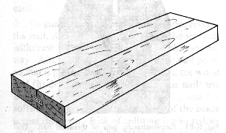

A. Fitted with a or a

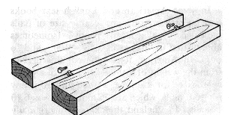

B.
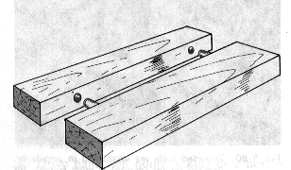

C.

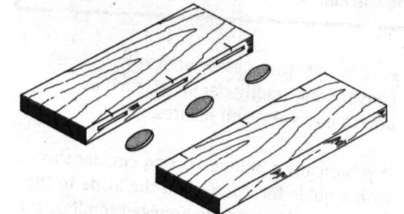

D.

16) When preparing boards for a widening joint how can the edges tested for straightness by;
Place the following words into your spelling list
Straightness Framing Bridle Tenon Barefaced

Module 4: Marking out tools
Complete the table on the next two pages.
Tool | Description |  | Uses
Marking Knife
Wing Compass
Inside Calipers
Outside Calipers
Try Square
Tool |  | Description |  | Uses
Sliding Bevel
Marking Gauge
Mortise Gauge
Pencil Gauge

Using a Marking or Mortise Gauge:
Use the following diagrams to help explain the correct procedure in setting and using a Marking or mortise gauge.

Add these words to your spelling list:
Try Square Combination Stock Thumbscrew Gauging

Module 5: Chisels
Research images of chisels to match the descriptions and pictures of chisels on the following pages and paste them into the table below so that they suit the description. See page 24 for the list.

Name | Description | Image
 | Have a shorter blade than other chisels, which can be either bevel edged or rectangular in shape like a firmer chisel. Some brands are available in widths up to 5Omm or more, which are used mainly for cutting recesses for butt hinges and locks.
 | General-purpose chisels with a rectangular blade, used mainly for heavier applications of bench work.
 | Are not designed for use with a mallet. The blade is usually thinner and the edges are finer than an ordinary bevelled edge chisel. The cutting edge is sometimes ground and sharpened to a slightly more acute angle than other chisels to make hand paring with the chisel a little easier. The paring chisel is generally used with a slicing action in shaping and carving operations.
 | Are similar to chisels, except that the blades are curved in cross section and are used for general carving, grooving and fluting. Gouges with the grinding bevel on the inside are called scribing or paring gouges. These are also used for some carving operations and for scribing mouldings.
 | Generally used for fine work such as cutting dovetails where the bevelled edge allows the chisel to fit into acute angled corners of the joint.
 | Are often used for heavy work. The handle is fitted into a cone shaped socket on the end of the blade. This enables the handle to stand up to heavy work with less chance of splitting. The illustration above shows a socket mortice chisel, however other types such as bevelled edge chisels are sometimes available as socket chisels.
 | Have a thick blade and are used for the heaviest work, such as cutting mortices, where the waste is levered out of the mortice with the chisel and the mallet is used with more force than for other applications. Mortice chisels are sometimes called registered mortice or registered firmer chisels.
 | Are sometimes called carpenters mallets or joiners mallets. They are used to strike chisels when removing waste material in woodwork jointing operations. The mallet is preferred to a hammer because it is less likely to damage the handle of the chisel.

Write the following words into your spelling list
Chisel Socket Firmer Lever Carpenter

Names of Chisels.
Name
Paring chisels
Bevelled edge chisels
Wooden mallets
Firmer chisels
Butt chisels
Mortice chisels
Firmer gouges
Socket chisels

Module 6:Planes

Planes are used to smooth and straighten the faces and edges of timber and to prepare pieces of timber to the sizes and shapes required. The illustration below shows the main parts of a typical plane. All planes have basically the same parts and are adjusted and used in the same way.

Label the Parts of the Plane from the list below and neatly colour in the plane

Parts of a Plane

The or (blade) is screwed to the , keeping the leading edge of the cap iron one or two millimetres back from the cutting edge. The plane iron and cap iron are then held in place on the with the
. The cut depth is adjusted by turning the clockwise to decrease the depth of cut. The cut depth is set to suit the type of work being done. For example, fine finishing work would require a very fine cut, while fast waste removal would be performed with a deeper or heavier cut. The
is used to adjust the blade so that the cutting edge is parallel to the of the plane in the . Planes should be kept sharp, free from rust and glue and always stored in a way that protects the cutting edge.
Frog, Sole, Plane iron, Lever Cap, Adjustment nut, Cap iron, Stock, Mouth, Lateral Adjustment lever, Handle, Knob.

Types of Planes
Cut out the diagrams of planes on the following page and position the matching pictures beside the correct descriptions below.

Smoothing planes are used mainly for fine finishing work. The cut depth is set to make the finest possible cut. Length is usually in the range from 230 to 260mm. Width varies to suit the blade sizes which are 45, 50 and 6Omm.

Jack planes can be used for different types of work. They are general-purpose planes, which can be set for fairly fine finishing work as well as for fast waste removal. Length varies from 350 to 380mm and blade widths are usually 50 or 60mm.

Try planes (or trying planes) are used to straighten long edges. A typical example in the workshop is straightening the edges of boards that are to be joined to make a solid timber tabletop. The extra length of the try plane is also used to advantage in achieving perfectly flat surfaces. Length varies from 500 to 6OOmm and blade width is usually 6Omm.

Block planes are small rigidly constructed planes designed to be used in one hand. They can be finely adjusted and are used for planing end grain, such as small mitres or chamfers. Length varies from 125 to 2OOmm and blade widths are usually 32 or 45mm.

Spokeshaves are used to smooth curved edges. They have a blade and cap iron similar to a plane and work in much the same way

Write the following words into your spelling list

Spelling Words: Planes Edges Millimetres Adjustments Clockwise

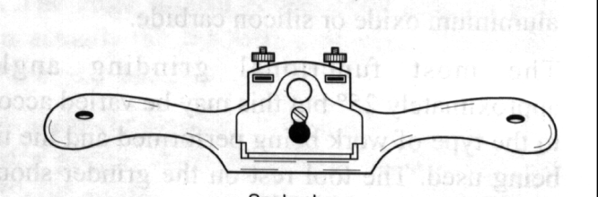

Diagrams of Chisels

Module 6 :Planes

Planes are used to smooth and straighten the faces and edges of timber and to prepare pieces of timber to the sizes and shapes required. The illustration below shows the main parts of a typical plane. All planes have basically the same parts and are adjusted and used in the same way.

Label the Parts of the Plane from the list below and neatly colour in the plane

Parts of a Plane

The or (blade) is screwed to the , keeping the leading edge of the cap iron one or two millimetres back from the cutting edge. The plane iron and cap iron are then held in place on the with the . The cut depth is adjusted by turning the clockwise to increase the depth and anti-clockwise to decrease the depth of cut. The cut depth is set to suit the type of work being done. For example, fine finishing work would require a very fine cut, while fast waste removal would be performed with a deeper or heavier cut. The
is used to adjust the blade so that the cutting edge is parallel to the of the plane in them . Planes should be kept sharp, free from rust and glue and always stored in a way that protects the cutting edge.
Frog, Sole, Plane iron, Lever Cap, Adjustment nut, Cap iron, Stock, Mouth, Lateral Adjustment lever, Handle, Knob.

Types of Planes
Cut out the diagrams of planes on the following page and position the matching pictures beside the correct descriptions below.

Smoothing planes are used mainly for fine finishing work. The cut depth is set to make the finest possible cut. Length is usually in the range from 230 to 260mm. Width varies to suit the blade sizes which are 45, 50 and 6Omm.

Jack planes can be used for different types of work. They are general-purpose planes, which can be set for fairly fine finishing work as well as for fast waste removal. Length varies from 350 to 380mm and blade widths are usually 50 or 60mm.

Try planes (or trying planes) are used to straighten long edges. A typical example in the workshop is straightening the edges of boards that are to be joined to make a solid timber tabletop. The extra length of the try plane is also used to advantage in achieving perfectly flat surfaces. Length varies from 500 to 6OOmm and blade width is usually 6Omm.

Block planes are small rigidly constructed planes designed to be used in one hand. They can be finely adjusted and are used for planing end grain, such as small mitres or chamfers. Length varies from 125 to 2OOmm and blade widths are usually 32 or 45mm.

Spokeshaves are used to smooth curved edges. They have a blade and cap iron similar to a plane and work in much the same way

Write the following words into your spelling list

Spelling Words: Planes Edges Millimetres Adjustments Clockwise

Extension Work

Module 7: Technical Drawing

Many different kinds of drawing are used in industry and commerce including different forms of graphic design, technical drawing, engineering drawing and architectural drawing as well as freehand sketching. Formal drawings and sketches can be computer generated or executed manually. The methods are many and varied, but all have a common element. They are all forms of communication which convey information or ideas.

1. Why must the furniture designer have graphic communication skills?

2. Why must workshop personnel such as cabinet makers, also have skills in graphic communication?

Freehand sketches:
are often used in preliminary design work to:

1
2
3

3. A perspective or other type of pictorial sketch is usually best. Why?

4. Some of the advantages of using freehand sketching as a design tool are:

5. Why must Proportions be maintained in a freehand sketch?

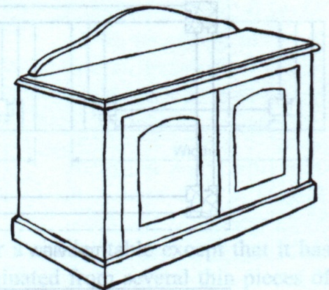
Drawing a Freehand Sketch.
Use the information below as a guide to draw your own Freehand Front and Side Drawing of this Cabinet in Sketchup.

Your completed Sketch is to contain all the information seen in the sketch below including the dimensions.

Give your Sketch a Title.

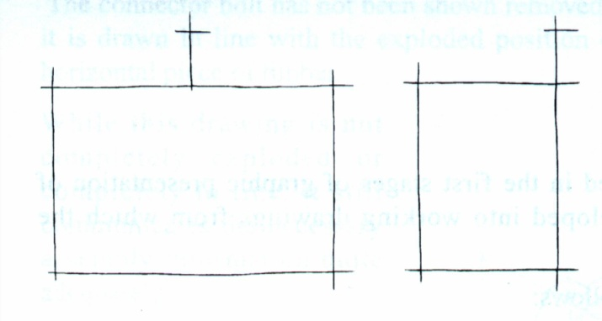
The illustration on the left shows the first stage of the required sketch with the proportions established.
The rectangular shapes which represent the overall sizes of the cabinet are drawn first to help establish the correct proportions of the length, width and height.

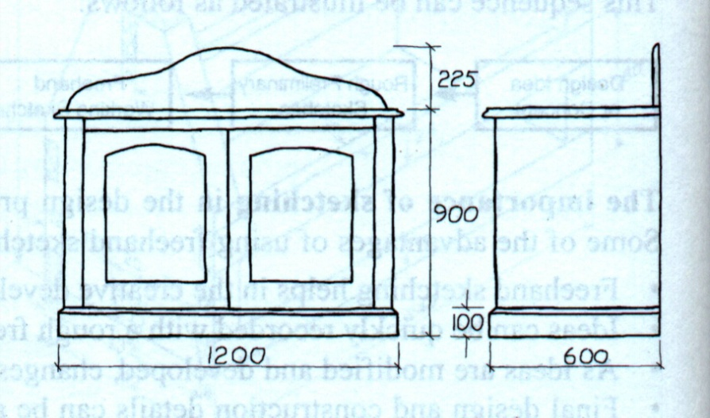

The illustration on the right shows detail added to the sketch. As the detail is added to the sketch, proportions can be maintained by estimating or roughly measuring sizes of detail in relation to the established sizes or proportions.

For example, say the height to the cabinet top is to be 9OOmm and the
base is to be 1OOmm high.
The 9OOmm measurement is already established and the base can be estimated or roughly measured at one ninth of the height.

Place the following words into your spelling list;

Technical Proportion Freehand Communication Estimating

Module 8: Pictorial Drawings

1. What is the difference between freehand and pictorial drawings?
2. Correctly drawn pictorials are used in preference to freehand sketches when:

1
2
3

The illustrations below show pictorial drawings of a simple occasional table drawn with isometric, perspective and oblique drawing methods.
Some people have difficulty in visualising the shape and form of an article presented with two dimensional views such as a multi-view orthographic drawing.

3. When are pictorial drawings often used?
4. How is an Isometric Drawing created?

5. Use the following simple steps to assist you in drawing your own isometric table frame on the following page.

Add the following words to your spelling list;
Pictorial Isometric Degrees visualizing vertically

Steps in Drawing an Isometric Drawing
The illustrations below show four simple steps in making an isometric drawing of a table

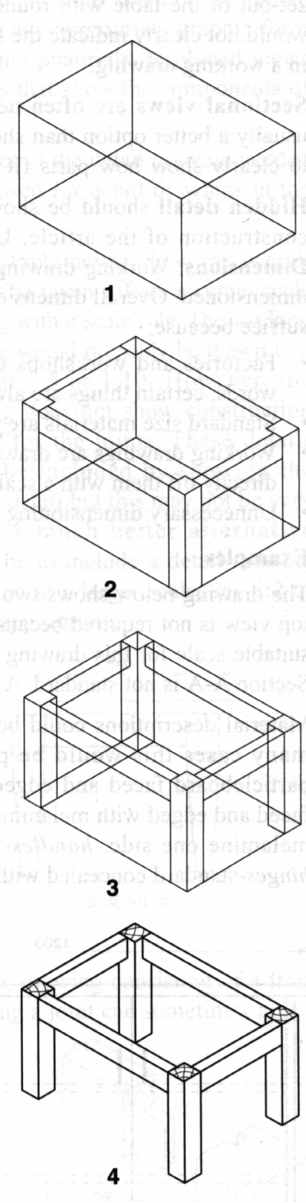
Step 1:
Draw a box to enclose the isometric view of the table frame. The vertical corners of the box are equal to the height of the frame, the corners, which make 30 degrees to the left, are equal to the length of the frame and the corners which make 30 degrees to the right are equal to the width of the frame. In a pencil drawing the box should be drawn as lightly as possible.

Step 2:
Lightly draw the shape of the front view from the orthographic projection on the front of the isometric box, the end view on the end of the box and the top view on the top of the box.

Step 3:
Complete the remainder by drawing lines at 30 degrees to the right, 30 degrees to the left and vertically as required.

Step 4:
Erase or delete unnecessary lines and lines which are not visible. Complete the outline in accordance with the appropriate presentation standard.

Isometric Table Frame

Module 10 :Orthographic drawings

1. What do Orthographic drawings consist of?

2. Why are most Working Drawings done in multi-view projections?

3. How can objects that are too large to fit on paper be drawn?

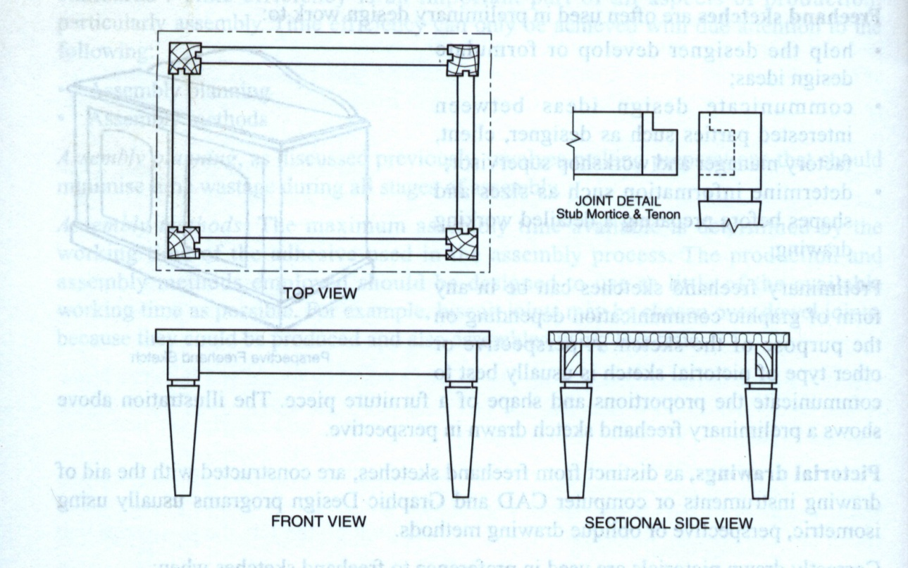
4. What Australian Standard should be used on working drawings?

5. What do the drawing standards provide?

Sheet layout should be in the form illustrated below, with margins and border lines.

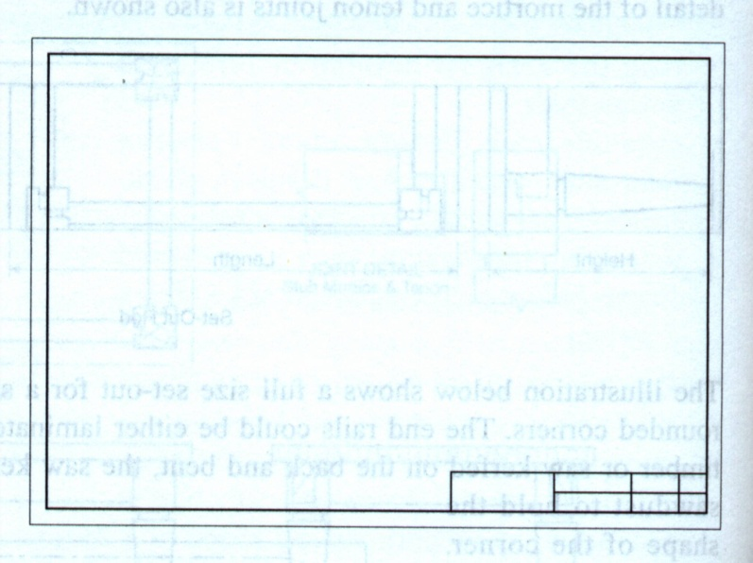

6. Where should the title block be located on drawings?

7. What basic information should a title block contain?

8. Multi-view orthographic drawings consist of two-dimensional views, which are aligned, in a certain way.
The diagram on the right shows how views can be set up in an orthographic drawing.

What do the rectangles represent?

9. How should these rectangles be spaced?

10. What is the 45 degree line for?
11. What is meant by projecting measurements from one view to another?
12. How is the drawing completed once all views are added?
13.Exercise: Drawing Analysis

The surfaces of the pictorial view have been identified by a letter.
The surfaces and edges of surfaces in the orthogonal projection have been identified by a number.
Complete the table with the numbers that correspond to the surfaces lettered in the pictorial view

 | A | B | C | D | E | F
TOP
FRONT
RIGHT SIDE

Orthographic Drawing Exercise;

Complete the Drawing of the Lock Plate in Sketchup.

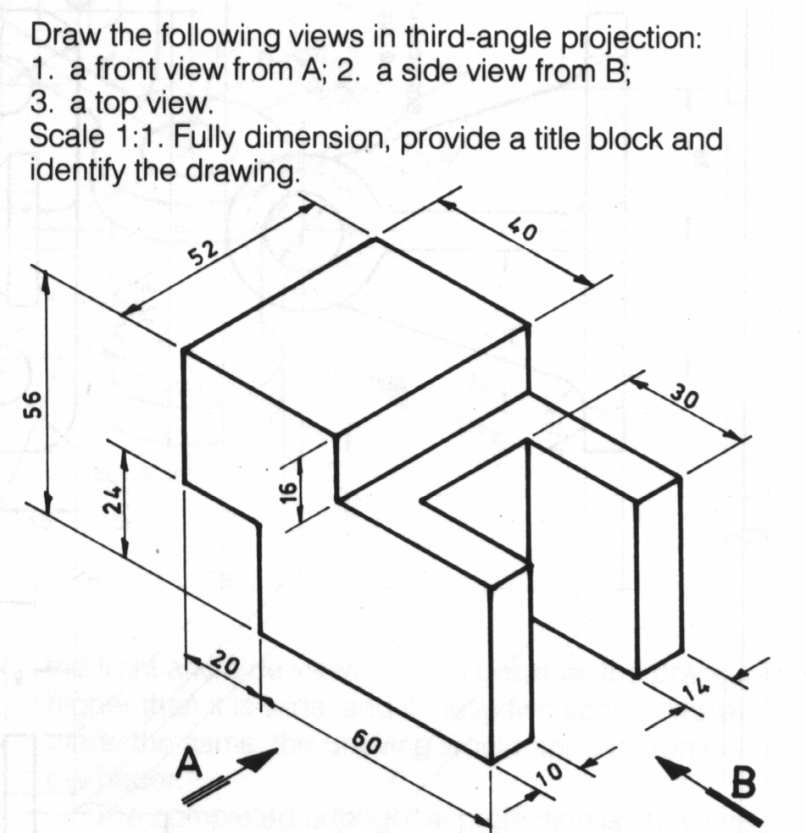

Write the following words in your spelling list:
Orthographic

End of book

